**PROSIT 1**

**KEYWORDS a**

1. Optimize property offers – it refers to the process of tailoring and improving the selection of real estate listings presented to potential buyers.
2. Artificial Intelligence - A field of technology that uses algorithms and computational systems to perform tasks that typically require human intelligence, such as data analysis, pattern recognition, and decision-making.
3. Dataset - A collection of structured data used for analysis.
4. Census tract - A geographical region defined for the purpose of census data collection.
5. Hierarchical ascending classification - A clustering method that builds a hierarchy of groups by iteratively merging the closest pairs of data points based on a distance metric.
6. Dendrogram - A tree-like diagram that illustrates the hierarchical relationships between data points in a dataset.
7. K-means algorithm - A clustering algorithm that partitions a dataset into 𝑘 groups (clusters) by minimizing the variance within each group.
8. Intelligent analysis - Refers to the process of leveraging computational techniques, such as machine learning or statistical algorithms, to extract meaningful patterns and insights from data.

**CONTEXT a**

To optimize its real estate offers and reduce the number of required visits, Loft’s Craft is turning to AI to achieve its goals and improve its performance and services.

**CONSTRAINTS a**

* Dataset
* K-means algorithms
* Value of K=2

**PROBLEM STATEMENT a**

How can AI techniques be used to analyze real estate data, enabling Loft’s Craft to optimize property recommendations and minimize unnecessary client visits?

**DELIVERABLE a**

Jupyter notebook with clean and treated data

**SOLUTION APPROACH a**

* Data Wrangling
* Use K-means algorithm
* Use machine learning
* Provide an intelligent analysis of the data

**ACTION PLAN a**

1. Study AI (Principles, advantages, disadvantages...)
2. Study machine learning algorithms (k-means, HAC)
3. Pre-process, Clean, and treat the data

**ARTIFICIAL INTELLIGENCE A**

Artificial intelligence (AI) is technology that enables computers and machines to simulate human learning, comprehension, problem solving, decision making, creativity and autonomy.

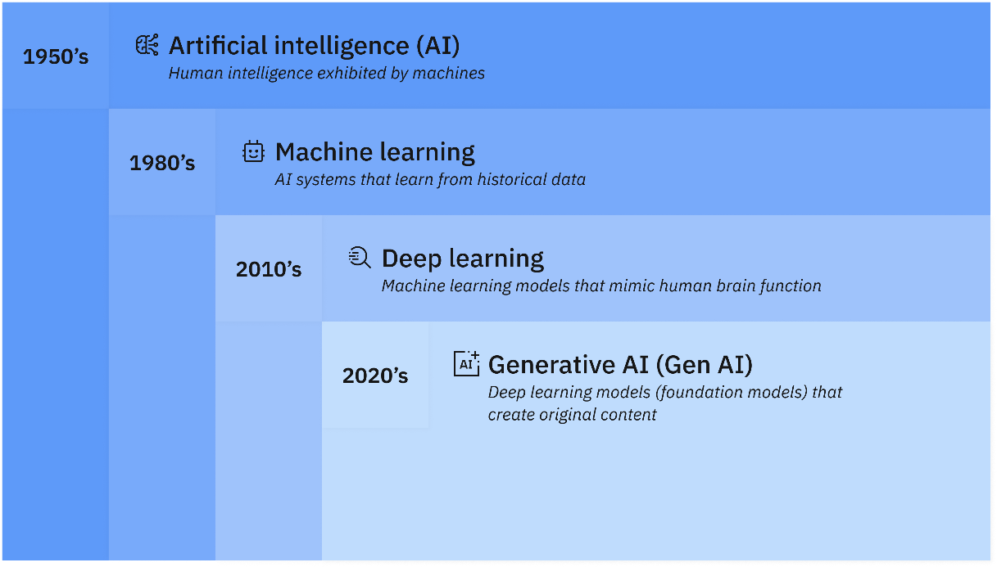

**Goals of AI**

* Replicate human intelligence
* Solve Knowledge-intensive tasks
* An intelligent connection of perception and action
* Building a machine which can perform tasks that requires human intelligence such as:
  + Proving a theorem
  + Playing chess
  + Plan some surgical operation
  + Driving a car in traffic
* Creating some system which can exhibit intelligent behaviour, learn new things by itself, demonstrate, explain, and can advise to its user.

**Advantages of AI**

* Accuracy with less errors: AI machines or systems are prone to less errors and high accuracy as it takes decisions as per pre-experience or information.
* Speed: AI systems can be of very high-speed and fast-decision making, because of that AI systems can beat a chess champion in the Chess game.
* Reliability: AI machines are highly reliable and can perform the same action multiple times with high accuracy.
* Useful for risky areas: AI machines can be helpful in situations such as defusing a bomb, exploring the ocean floor, where employing a human can be risky.
* Digital Assistant: AI can be very useful to provide digital assistance to the users Eg. E-commerce websites to show the products as per customer requirement.
* Useful as a public utility: AI can be very useful for public utilities such as a self-driving car which can make our journey safer and hassle-free, facial recognition for security purpose, Natural language processing to communicate with the human in human-language, etc.

**AI challenges and risks**

* Data risks
  + AI systems rely on data sets that might be vulnerable to data poisoning, data tampering, data bias or cyberattacks that can lead to data breaches. Organizations can mitigate these risks by protecting data integrity and implementing security and availability throughout the entire AI lifecycle, from development to training and deployment and post-deployment.
* Model risks
  + Threat actors can target AI models for theft, reverse engineering or unauthorized manipulation. Attackers might compromise a model’s integrity by tampering with its architecture, weights or parameters; the core components that determine a model’s behaviour, accuracy and performance.
* Operational risks
  + Like all technologies, models are susceptible to operational risks such as model drift, bias and breakdowns in the governance structure. Left unaddressed, these risks can lead to system failures and cybersecurity vulnerabilities that threat actors can use.

**AI ethics and governance**

* Explainability and interpretability
  + As AI becomes more advanced, humans are challenged to comprehend and retrace how the algorithm came to a result. Explainable AI is a set of processes and methods that enables human users to interpret, comprehend and trust the results and output created by algorithms.
* Fairness and inclusion
  + Although machine learning, by its very nature, is a form of statistical discrimination, the discrimination becomes objectionable when it places privileged groups at systematic advantage and certain unprivileged groups at systematic disadvantage, potentially causing varied harms. To encourage fairness, practitioners can try to minimize algorithmic bias across data collection and model design, and to build more diverse and inclusive teams.
* Robustness and security
  + Robust AI effectively handles exceptional conditions, such as abnormalities in input or malicious attacks, without causing unintentional harm. It is also built to withstand intentional and unintentional interference by protecting against exposed vulnerabilities.
* Accountability and transparency
  + Organizations should implement clear responsibilities and governance structures for the development, deployment and outcomes of AI systems. In addition, users should be able to see how an AI service works, evaluate its functionality, and comprehend its strengths and limitations. Increased transparency provides information for AI consumers to better understand how the AI model or service was created.
* Privacy and compliance
  + Many regulatory frameworks, including GDPR, mandate that organizations abide by certain privacy principles when processing personal information. It is crucial to be able to protect AI models that might contain personal information, control what data goes into the model in the first place, and to build adaptable systems that can adjust to changes in regulation and attitudes around AI ethics.